Class Work: Word Embeddings

Title : Class Work: Word Embeddings using Natural Language Processing

Objective : The objective of this class work is to understand the concept of Word Embeddings and implement them using Python to represent words in a numerical vector form that captures semantic and syntactic relationships between words.

Tools and Technologies Used
- Programming Language: Python
- Libraries:
  - nltk / gensim / sklearn (depending on implementation)
  - numpy
- Platform: Google Colab

Theory
Word Embeddings are a technique in Natural Language Processing (NLP) where words are represented as dense numerical vectors instead of sparse representations like one-hot encoding.
Unlike traditional methods, word embeddings capture:
- Semantic meaning
- Contextual similarity
- Relationships between words (e.g., king − man + woman ≈ queen)
Popular word embedding techniques include:
- Word2Vec
- GloVe
- FastText
These embeddings are widely used in NLP tasks such as sentiment analysis, machine translation, text classification, and question answering.

Types of Word Embeddings
- One-Hot Encoding
  - Simple but inefficient
  - Does not capture word relationships
- Word2Vec
  - Uses neural networks
  - Models: CBOW and Skip-Gram
- GloVe
  - Based on global word-word co-occurrence statistics
- FastText
  - Considers subword information
  - Handles rare and unseen words effectively

Algorithm / Workflow
- Collect and preprocess text data
- Tokenize the text into words
- Build vocabulary
- Train word embedding model
- Convert words into vector representations
- Analyze similarity between words

Implementation (Sample Code – Word2Vec)
from gensim.models import Word2Vec
from nltk.tokenize import word_tokenize
import nltk

nltk.download('punkt')

# Sample text
sentences = [
"Word embeddings capture semantic meaning",
"Natural language processing uses word vectors",
"Word2Vec is a popular embedding technique"
]

# Tokenize sentences
tokenized_sentences = [word_tokenize(sentence.lower()) for sentence in sentences]

# Train Word2Vec model
model = Word2Vec(
sentences=tokenized_sentences,
vector_size=50,
window=5,
min_count=1,
workers=4
)
# Get vector for a word
vector = model.wv['word']
print(vector)

Output
- Words are converted into dense numerical vectors
- Similar words have similar vector representations
- Vector size depends on the configuration (e.g., 50 dimensions)

Result
Word embeddings were successfully generated from the given text corpus. The model learned meaningful vector representations of words, enabling similarity comparison and semantic understanding.
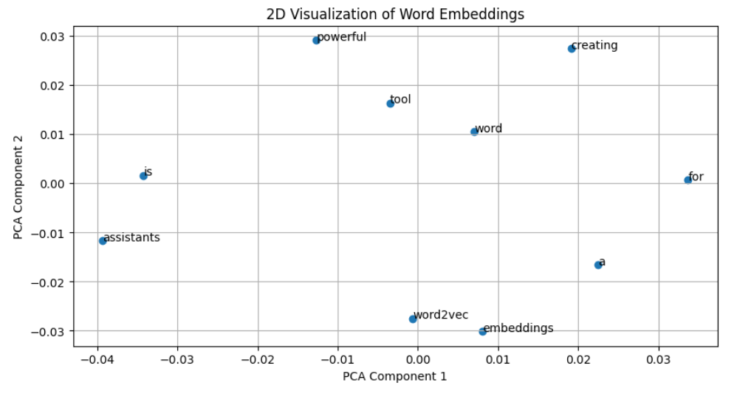
Conclusion
Word embeddings provide an efficient way to represent text data for machine learning models. By capturing semantic relationships between words, embeddings significantly improve the performance of NLP applications compared to traditional encoding techniques.

Applications
- Sentiment Analysis
- Machine Translation
- Text Classification
- Information Retrieval
- Chatbots

Future Scope
- Use pre-trained embeddings like GloVe or FastText
- Visualize word vectors using PCA or t-SNE
- Apply embeddings in deep learning models (LSTM, Transformers)

References
- Jurafsky & Martin – Speech and Language Processing
- Gensim Documentation
- NLTK Documentation

